Pull requests
Pull requests on GitHub are like asking permission to change something in a project. It's a way to propose your code changes to the project's owners for review and approval before they become part of the official code.
GitHub Actions
GitHub Actions, on the other hand, are tools that can automatically do tasks whenever something happens in a GitHub project, like when a pull request is made or updated.
So, pull requests and GitHub Actions work together: when you make a pull request, GitHub Actions can automatically run tests, check your code for errors, or even deploy your changes to a website for preview. This automation helps teams work faster and ensures that code changes are checked thoroughly before they're merged into the main project.
Workflows
Think of workflows on GitHub like a set of instructions you give to GitHub so it can automatically do things for you whenever something specific happens in your project.
Imagine you have a magic assistant that waits for certain events, like when you add new code or someone suggests changes (a pull request). When these events occur, your assistant follows the steps you've written down to automatically run tests, check for errors, or even publish your project online.
In simple terms, workflows automate tasks on GitHub, making your development process smoother and more efficient by handling routine jobs without you having to do them manually every time.

Continuous Integration (CI):
Imagine you're working on a team project where everyone adds their code changes to a shared codebase. Here's how CI helps:
Example:
- You and your team members are working on an app. Each of you develops new features or fixes bugs independently.
- With CI, every time someone finishes their code and wants to add it to the main codebase (usually through a pull request on GitHub), CI kicks in.
- CI automatically runs tests on the new code to make sure it doesn't break anything that was working before. These tests could include checking if the app still loads, if buttons work correctly, etc.
- If the tests pass, it's a good sign that the new code integrates well with the existing codebase. If tests fail, developers are notified, and they can fix issues early.

Continuous Deployment (CD):
Now, let's say your team wants to make sure that whenever code changes are approved and tested, they get automatically deployed to users without manual steps:
Example:
- After passing CI tests, the code is automatically deployed to a server where users can access it. For example, if you're working on a website, the changes are automatically made live on the website for visitors to see.
- CD ensures that the process from writing code to deploying it for users is seamless and quick. It minimizes the time between writing new features or fixing bugs and making them available to users.

Simple Example:
- Scenario: We're part of a team building an online store website.
- Continuous Integration (CI):
We've developed a new feature that allows customers to filter products by price range.
Before merging your code into the main website codebase, CI runs automated tests to ensure that this new feature doesn't break any existing functionality like adding items to the cart or checking out. If all tests pass, your feature is considered safe to merge with the main codebase.
- Continuous Deployment (CD):
Once your feature is merged in and passes CI, CD automatically deploys this updated code to the live website. Now, customers visiting the website can use the new filter feature immediately without any delay.

Benefits:
Automation: CI/CD automate the process of testing and deploying code changes, saving time and reducing errors that could arise from manual processes.
Faster Feedback: Developers get quick feedback on whether their code works well with the rest of the system (CI) and can deliver new features to users faster (CD).
Higher Quality: By catching integration issues early (CI) and ensuring smooth deployments (CD), the overall quality of the software improves.
In essence, CI ensures code changes work well together, while CD ensures those changes reach users swiftly and safely. These practices are essential for modern software development, enabling teams to iterate quickly and deliver value to users consistently.

Example:
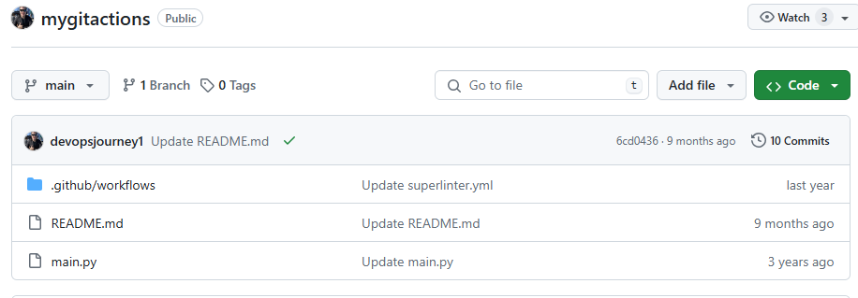
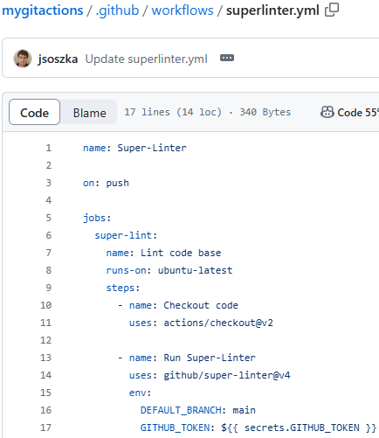

This custom GitHub Action configuration named “superlinter.yml” is designed to run a linting process on the codebase whenever there is a push to the repository. The linter used here is "Super-Linter," which is a GitHub Action for ensuring code quality by running a variety of linters on the repository's code.

Metadata

- name Super-Linter
  - This is the name of the GitHub Action. It can be anything descriptive of the action being performed.
- on push
  - This specifies that the workflow should be triggered whenever there is a push event to the repository. This includes pushing new commits, merging pull requests, etc.
Jobs

- jobs:
  - This section defines the jobs that will be run as part of the workflow. In this case, there is one job defined: super-lint.
Job: super-lint
- super-lint
  - This is the unique identifier for the job.
- name Lint code base
  - This is a human-readable name for the job. It describes what the job does, which is to lint the codebase.
- runs-on ubuntu-latest
  - This specifies the environment in which the job will run. Here, it is set to ubuntu-latest, meaning the job will run on the latest version of an Ubuntu runner provided by GitHub.
Steps
The steps section defines a series of steps that are executed as part of the job. Each step is a sequence of operations performed in the specified order.
- Checkout code
- name: Checkout code
uses: actions/checkout@v2
name: Checkout code
A human-readable name for the step.
uses: actions/checkout@v2
This specifies that the step uses the actions/checkout action at version v2. This action checks out the repository's code so that the workflow can access it. It essentially clones the repository into the runner environment.

- Run Super-Linter
name: Run Super-Linter
uses: github/super-linter@v4
env:
DEFAULT_BRANCH: main
GITHUB_TOKEN: ${{ secrets.GITHUB_TOKEN }}
  - name: Run Super-Linter
A human-readable name for the step.
  - uses: github/super-linter@v4
This specifies that the step uses the github/super-linter action at version v4. Super-Linter is a combination of multiple linters, and it runs various linting rules against the codebase to ensure code quality and consistency.
  - env:
DEFAULT_BRANCH: main
This sets an environment variable DEFAULT_BRANCH to main. Super-Linter uses this variable to know what the default branch is, which can be useful for certain checks and comparisons.
GITHUB_TOKEN: ${{ secrets.GITHUB_TOKEN }}
This sets the GITHUB_TOKEN environment variable. ${{ secrets.GITHUB_TOKEN }} is a special syntax used to access the automatically generated GitHub token, which is used for authenticating with the GitHub API. This token is necessary for certain operations, like posting comments on pull requests or reporting status checks.

This GitHub Action is set up to automatically run Super-Linter on the codebase every time there is a push to the repository. It performs the following steps:
- Checks out the repository’s code to the runner environment.
- Runs the Super-Linter to lint the codebase, ensuring that the code adheres to the specified coding standards and style guidelines.
By using this workflow, you can maintain code quality and consistency automatically with each push to the repository.

Example:

Error in the build

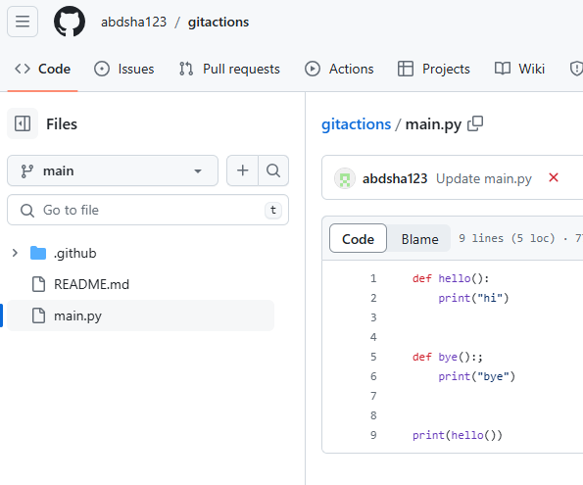
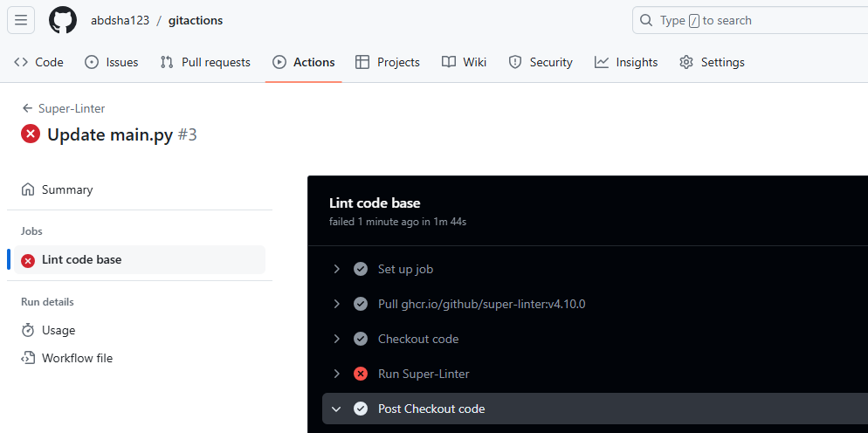

Correcting the error after conducting check:

